类别 ： POLYSPEC
POLYSPEC 甲板地坪

PolySpec® Marine Decking Products
PolySpec® provides the most comprehensive line of polymeric interior and exterior
deck coverings available for ships and offshore drilling platforms. These decorative
and functional systems are easy to install and provide longer service life than tile,
carpet or vinyl sheet products. They require no waxing or stripping, are fire retardant
and offer good wear properties and chemical resistance.

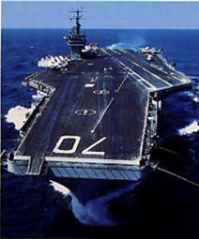

类别： AST

AST防滑涂料
AST NON-SKID COATING
安胜地™防滑涂层产品最初应用于美军航空母舰的甲板防滑。近40年的使用历程证明，该产品的防滑功能很好的保护了美国海军军人和设备操作安全。除此之外，AST®安胜地™防滑涂层还具有耐化学腐蚀、耐喷气机燃料、水性液体润滑油，油脂、原油以及含盐喷雾等特性。AST®安胜地™防滑涂层材料技术做为专门用于美国海军并通过测试和认证的唯一防滑产品。如果在您的工厂里应用，您可以享受到军事级别的防滑保护及比掺砂涂料长达五倍的使用期。

American Safety Technologies has been the leading manufacturer of non-skid coatings and interior polymeric decking systems for over 94 years.
Our non-skid coating are applied to all interior and exterior decks and our wide selection of ST-100 terrazzo, color flake systems, and underlayments applied in most areas on board including galleys, living quarters, wet spaces and can be found on almost every Navy vessel at home and abroad.
Our AST non-skid coatings are famous for their incredible toughness and durability. Originally engineered for use on the flight deck of U.S. Navy aircraft carriers, our coatings are tested to withstand over 15,000 high-impact jet landings per year.

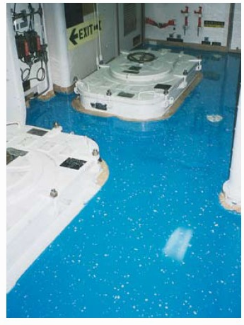
类别： Floating Floor System
FLOATING FLOOR SYSTEM

浮动地板系统

浮动地板改进了甲板上的结构性噪声的产生。
浮动地板系统可以应用于船舶底部可能产生撞击噪声的区域，也可以应用于船舶上部结构性噪声产生的地方。

